|  |
| --- |
| Portfolio Project |
| Large rock formation in rocky landscape under blue sky |

|  |  |
| --- | --- |
| 28/03/19 | USB Landing Page |

For this project I was asked to create a landing page for a USB drive that was to be given to clients at conferences.

PORTFOLIO PROJECT

USB Landing Page

I have been asked by Happy Ltd to create a landing page for a USB drive that would be given to clients after conferences.

Happy Ltd is a training provider based out of London, they are invested in creating better working environments and helping people get the best from themselves and their workplace.

The content of the page would a mix of videos, images and text to display the services that the company provides. I will be creating the page myself and will be corresponding with Claire (Digital Marketing Manager at Happy), who will act as a point of contact between myself and Happy.

I had originally created a landing page for this before, back at the end of 2017. I was not happy with the page I had created, as it was at the start of when I was learning to code and I did not know enough in my opinion.

All the work completed was done for free and I have been allowed to use this as a project to add to my portfolio.

# First version

For the first version of the page, I was given a hand drawn rough wireframe, colours and fonts to use and that was the extent of the information I had to work with, I didn’t feel confident enough in myself to go back and ask more questions so I worked with what I had. To get a better idea of the company’s brand, I went on to their website and looked at the styling that was used there, and then tried to recreate this in the page I was creating.

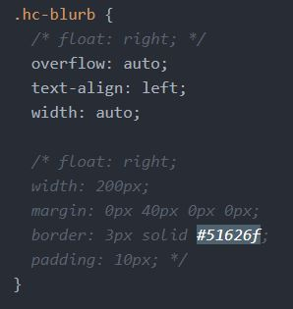My process for the creation of this page was not clear, and I didn’t run the project in a manner that was efficient or easy to follow. I found I jumped around a lot and didn’t focus on creating one element at a time. Because of this jumping around, I found that my code was messy, and I couldn’t clearly follow what was going on when I came to fix any issue that occurred. Sections were commented out to try to fix an issue, and then left in the code.

Although I created a page that functioned, I realised that I had taken on more work than I originally expected and thought I could do better.

Figure - The code used was messy and confusing, even to me as I was making it.

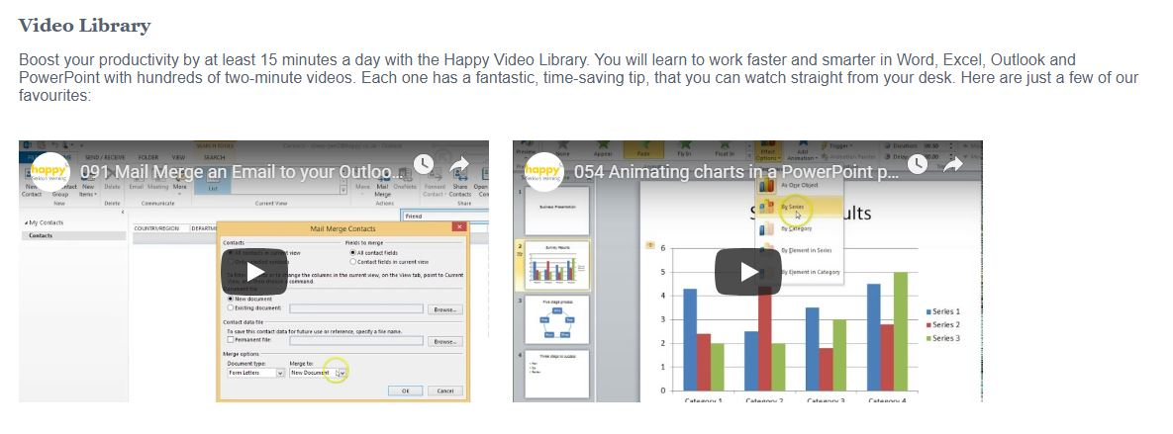

Figure - The content alignment was not to my liking.

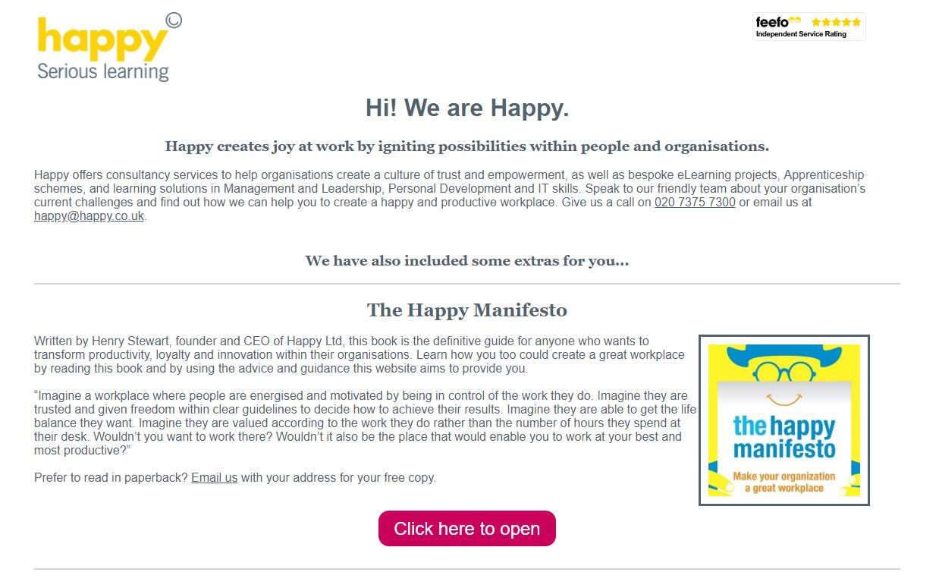

Figure - The layout for this felt a bit cramped.

# Version Two

Recently I was asked to create a second version of the landing page and was given comprehensive feedback from the staff at Happy.

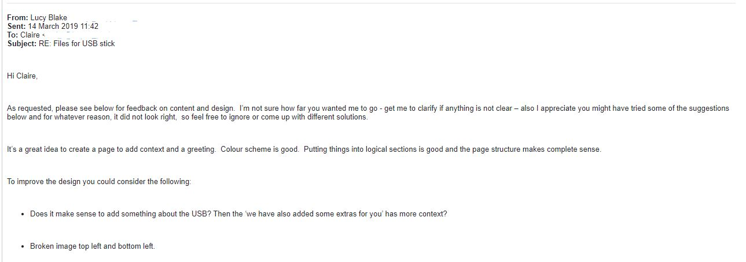

Figure - A sample of the feedback given.

I decided it would be easier to start over, and learning from my previous attempt at this task, I created a plan for the document. I clarified the design layouts and then created wireframes for the client to review different design options and see which fitted them best.

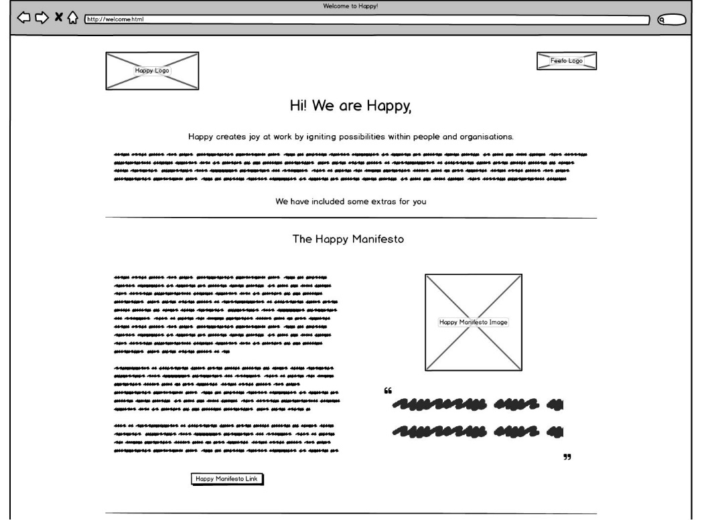

Figure - A wireframe design for the Introduction and Happy Manifesto sections of the page.

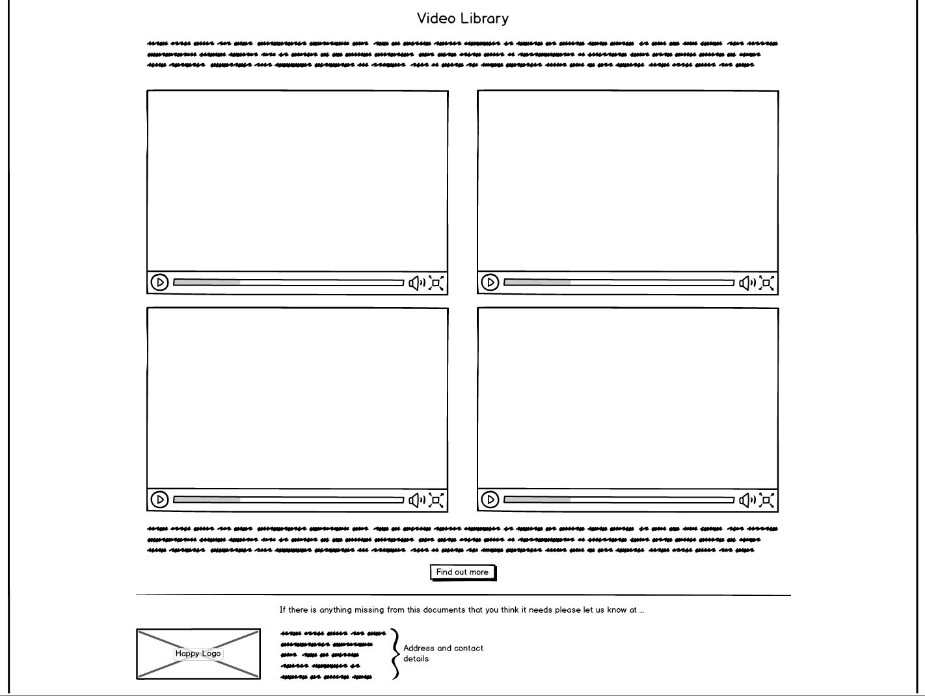

Figure - One of the wireframe designs for the Video Library and Footer section of the page.

Once the wireframes were created, I sent copies of them over to Claire to see which one they preferred. Once I knew the design they had chosen I was able to create more detailed mockups and send them over to Claire for approval.

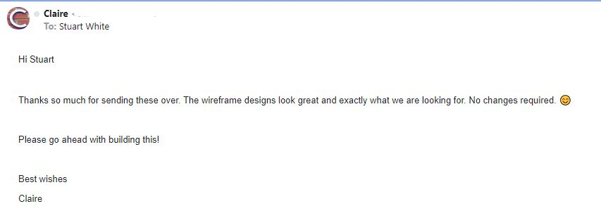

The first stage of my build process this time around was to input all of the content on the page before I began styling, so I could see what I was working with and follow and more methodical process without adding content in all over the place.

This allowed me to start styling the page and content having most of the content there. Once I had completed the majority of the styling I realized that my design may have to change slightly. To keep white space to a minimum and help with keeping the two columns of content in each section of a similar length, I needed to fill some space.

After talking to Claire about the issue, we decided that using quotes related to each section under the media would fill white space while still feeling like a natural element on the page.

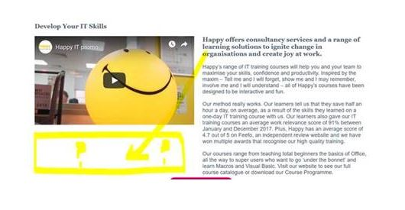

Figure - The white space below the video created an imbalance between the two columns.

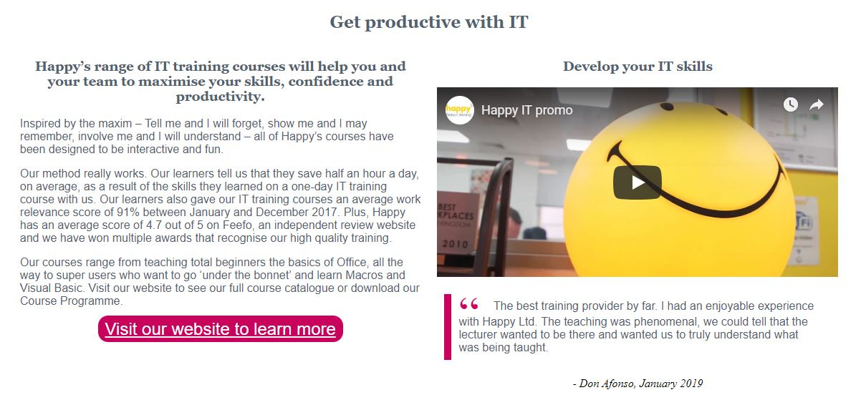

Figure - By adding a quote after the video I could balance the content of the two columns

By adding the quote, I found that as the page was resized the columns scaled much better than they had before as well. I was originally going to add a section in the CSS that would marginally adjust the font size as the page size changed, to keep the content in alignment, but with the quote in place I found that this was not needed.

For the styling on this page, I had a more detailed conversation with Claire about the company’s brand and how they wanted it to be implemented, and how it would relate to accessibility standards. Through the conversation we agreed on how individual elements would be styled so that they would be more accessible, including what the alternate text would be for each element.

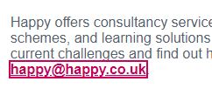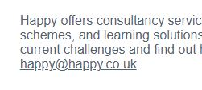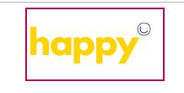

Figure , 10, 11 - Some of the options included for making links more accessible

Links would have different properties for when the page was being navigated with a keyboard, so the user could clearly see where they were on a page.

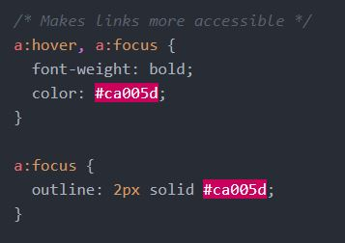

Figure - A segment of the code that made the page more accessible

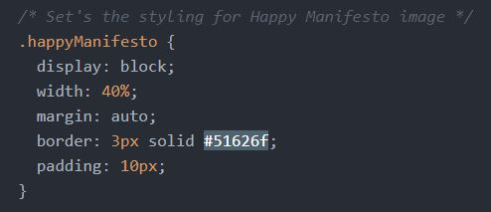

Figure – CSS Styling for the Happy Manifesto image

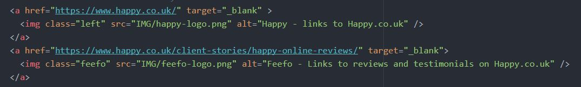

Figure - HTML code for the Happy logo and the Feefo logo

Once I had finished all the styling and accessibility compliance, I sent the finished page over to Claire for her and the other staff at Happy to sign off on the work. Claire has signed the work off, but has said she will pass any feedback on to me.

One thing I could have done for this project, and I may yet do in the future, is to write some documentation to allow staff at Happy to change the content on the landing page and keep it up to date. This will allow them to update the videos and text and keep the landing page stocked with fresh content.

All the code for the project can be found on my [CodePen](https://codepen.io/Stuart-White/pen/drxXOK).